Running the AIKOL Booking System
Ahmad Ibrahim Kulliyyah of Laws, IIUM
A guide for the Kulliyyah office: the administrators who run the system and the approvers who decide bookings. It covers everything the office does that a requester never sees. For booking a room or car yourself, the requester's user guide applies to you as well.
Address: https://aikol-booking-qn23bk3fqa-as.a.run.app

Who does what
Role | Can
Approver | Approve and reject booking requests, and see the booking history. Nothing else in the office pages.
Administrator | Everything: decisions, keys, venues and vehicles, people, reports, rules, site wording, data and the audit log.

On screen, requesters are told to "contact the Admin". That means you.
Every approver and administrator also has an ordinary account: you can make your own bookings in the same way as anyone else.

1. Signing in
Approvers and administrators sign in on the same page as everyone else, with their email address and password. No code from a phone is needed.

2. Finding your way around
The menu runs down the left side. Above the rule are your own pages (Home, My Bookings, Venue, Vehicles); below it is the office's work.
Menu | What is there | Section
Overview | What needs attention today | 3
Bookings | Every booking, the Awaiting Decision queue, and booking for someone else. The number beside it is how many requests are waiting | 4, 5
Keys | Keys to hand out, keys out, keys overdue | 6
Resources | Venues, vehicles and facilities, with photographs | 7
People | Every account and its role | 8
Insights | Reports and the bookings export | 9
System | Booking rules, email delivery, academic calendars, site wording, the wording of each email, data and the audit log | 10

An approver sees two entries instead: Queue (requests to decide) and History.
Most pages have a Back link at the top that returns to the list the page belongs to.

3. Overview
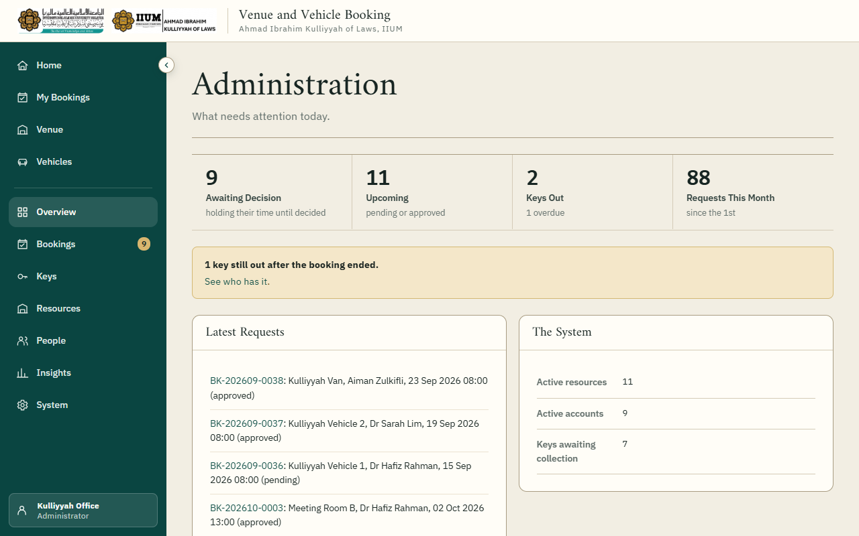
Overview: the figures across the top, then anything overdue, then the latest requests.
Start the day here. The figures show requests awaiting a decision, upcoming bookings, keys out and this month's requests. A yellow notice appears when a key is still out after its booking ended.

4. Deciding bookings

The booking register
Bookings lists every booking. The tabs switch between Venues, Vehicles and Awaiting Decision. Search by reference, person, email or resource, and filter by status.
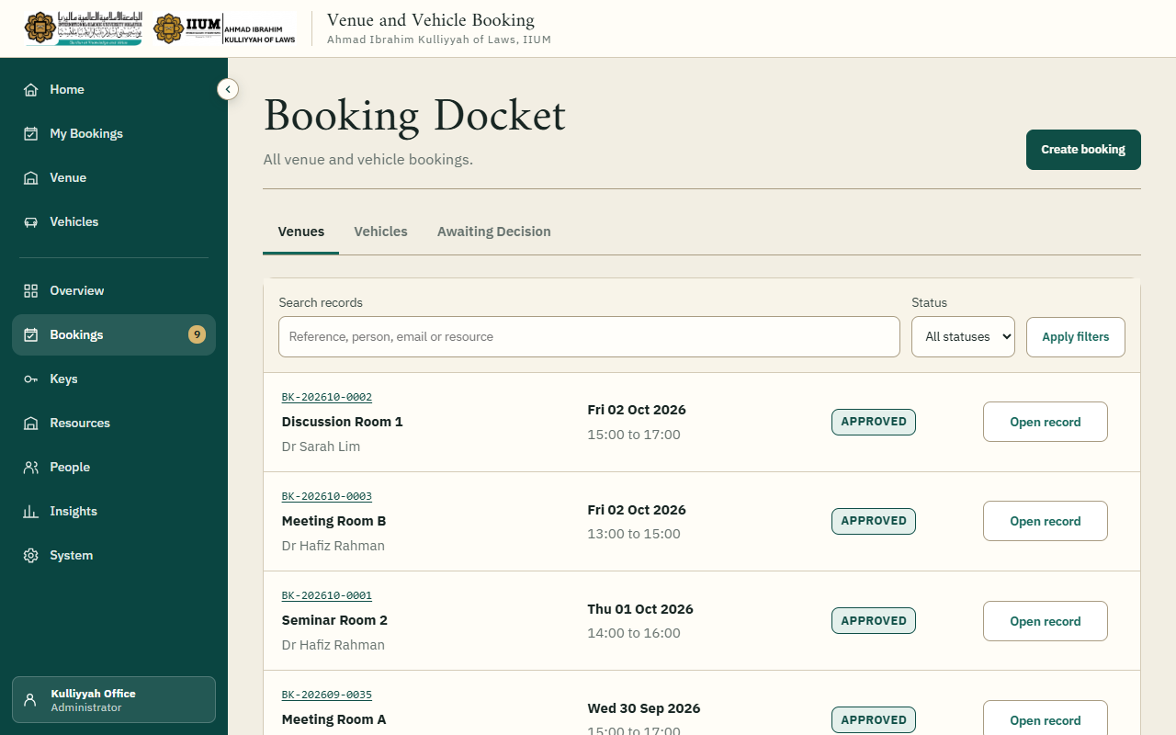
Bookings: every venue booking, newest first.

Awaiting Decision
The queue of pending requests, soonest first. Each has a Decide button.
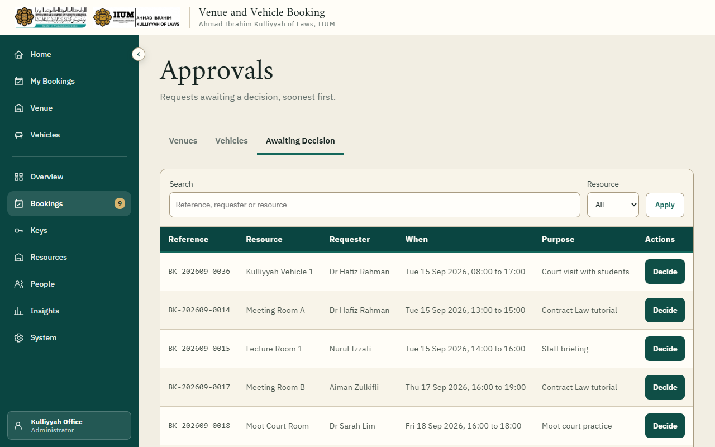
Awaiting Decision: pending requests, soonest first.

Approving or rejecting
Decide shows the request and any other booking that overlaps it.
- Approve needs no reason. The requester is emailed.
- Reject needs a reason, which the requester sees in their email.
The time is checked again as you approve. If somebody else's booking has been approved for the same time since, the approval is refused and the page says so. A warning appears if the request's start time has already passed.
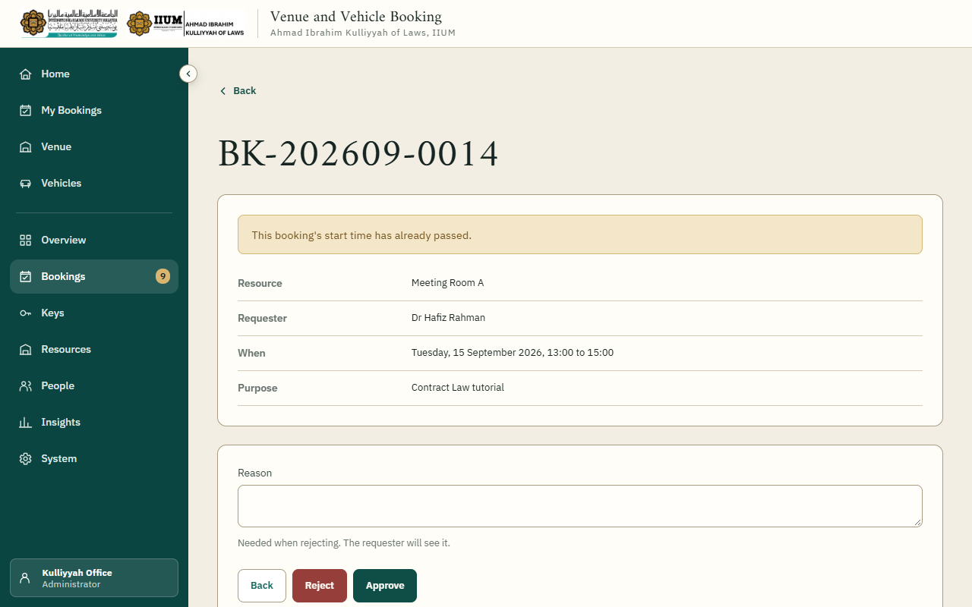
Decide: the request's details, then the reason and the two buttons.
A weekly series is decided as one: approving it approves every date that is still free and sends the requester a single email listing them.

Vehicle bookings: the second decision
A car needs two approvals. After the ordinary approval above, open the booking and choose
Management decision. Record Kulliyyah management's decision and, when approved, the VMU driver's name and contact number. The requester is emailed each time. The car's key cannot be issued until both approvals are in.
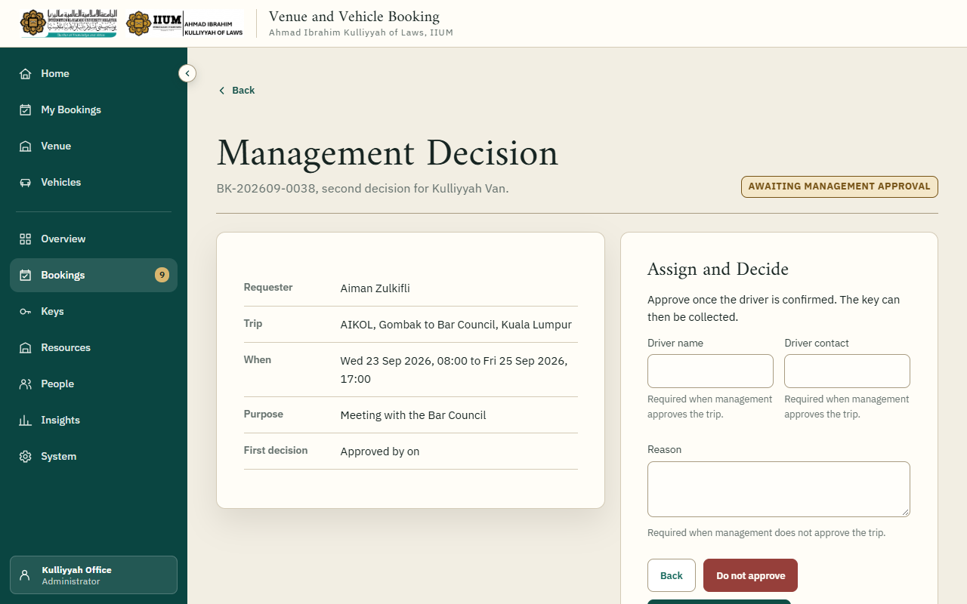
Management decision: the second approval for a car, with the driver.

Cancelling for someone
Open the booking and choose Cancel booking. A reason is required. The three-day notice that limits requesters does not apply to the office.

5. Booking for someone else
Under Bookings, choose Create booking, then the room or car. The form has a Booking for search: type a name, email or matriculation number and pick the person. The booking is recorded as made by you for them, and the confirmation goes to them. Leave the search empty to book for yourself.
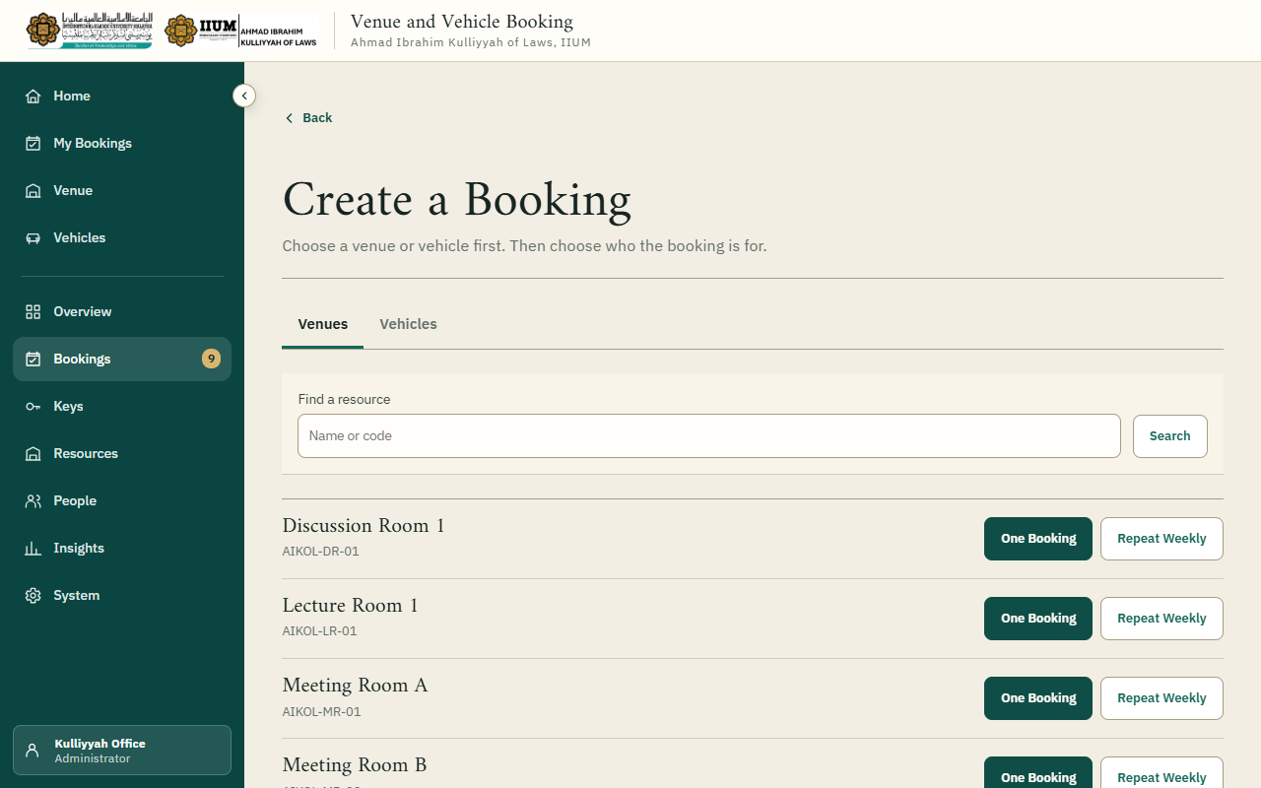
Create booking: choose the room or car first.

6. Keys
Keys has three lists: Awaiting Collection (approved bookings whose key is still with you),
Keys Out, and Overdue (still out after the booking ended).
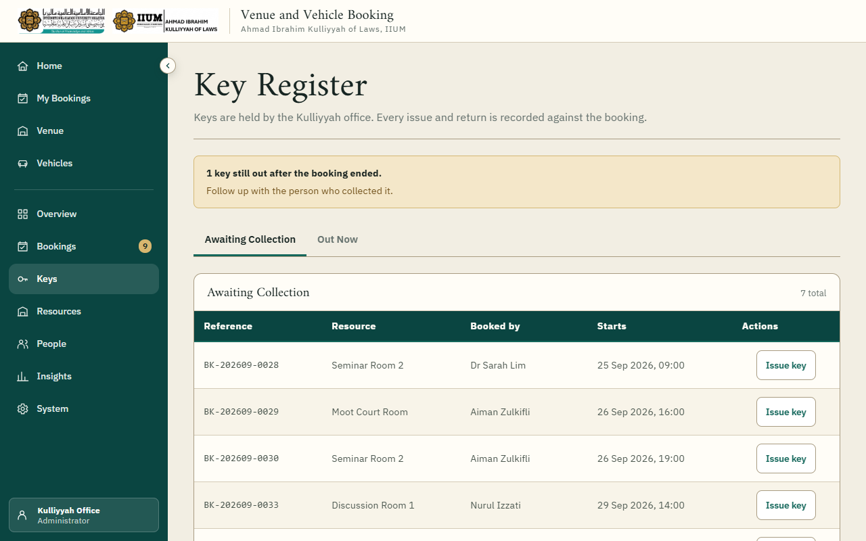
Keys: what to hand out, what is out, and what is overdue.
Issuing a key. Choose Issue key on the booking. If the person who booked is collecting it, leave Collected by blank and their name is recorded. If someone else comes, type that person's name and telephone number.
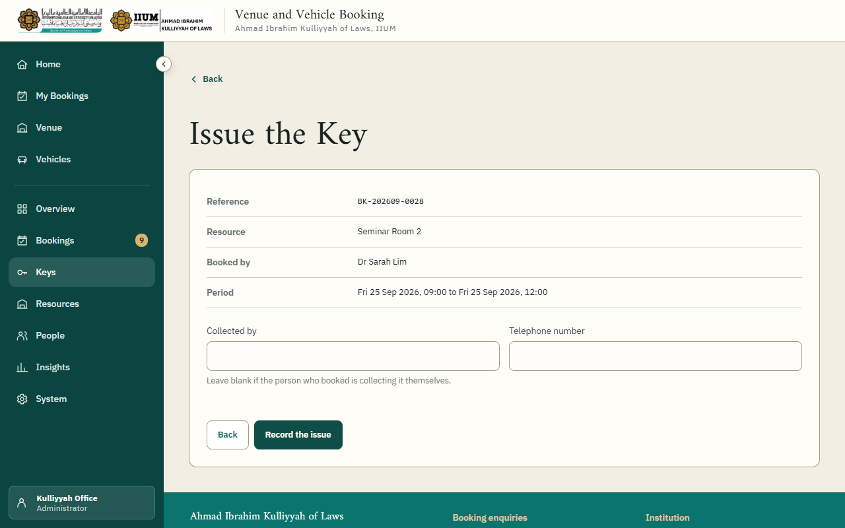
Issue the Key: leave Collected by blank when the person who booked collects it.
Taking a key back. Choose Record return on the key under Keys Out, record who handed it back, and note any damage or anything left behind.

7. Venues, vehicles and facilities
Resources has three tabs: Venues, Vehicles and Facilities.
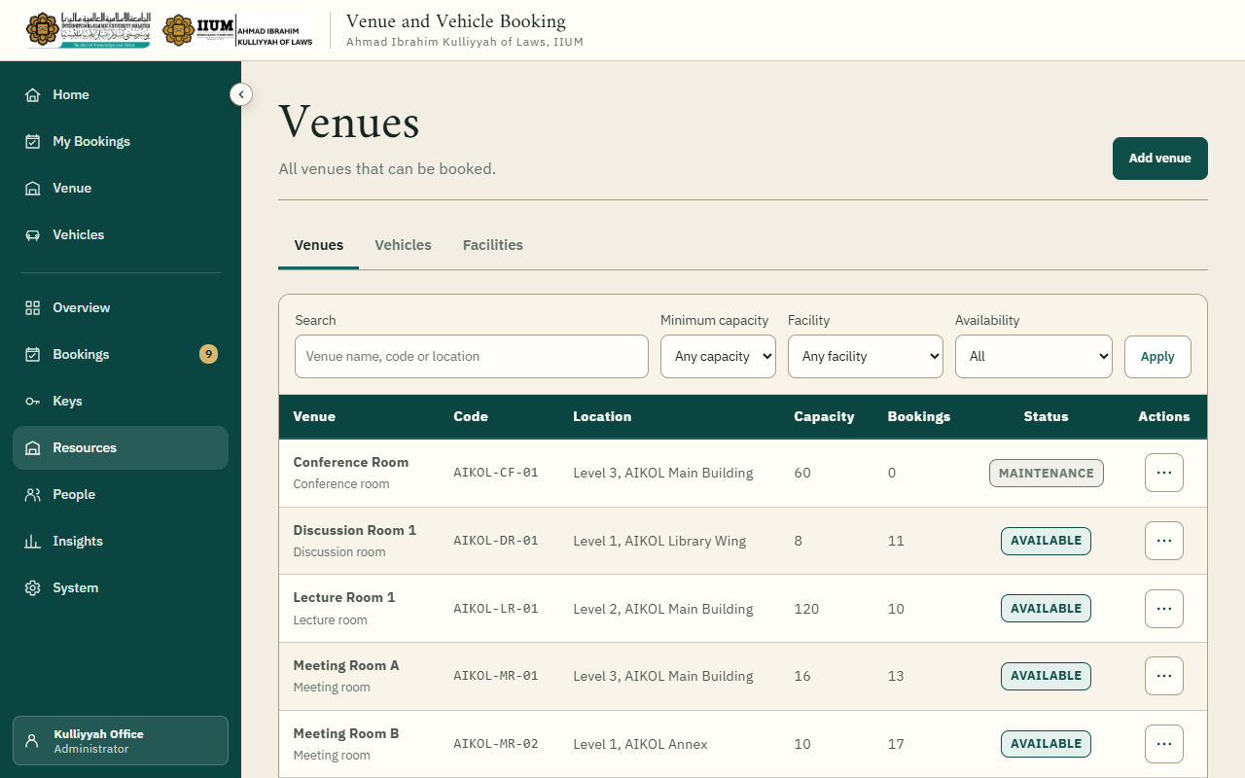
Resources, Venues: each venue with its status and actions.
Adding or editing. Choose Add venue (or Add vehicle), or Edit from a row's actions. A venue has a type, location, seats, opening hours and facilities. A vehicle has its registration number, make, model, seats and road tax expiry; a car past its road tax date is withdrawn from booking automatically.
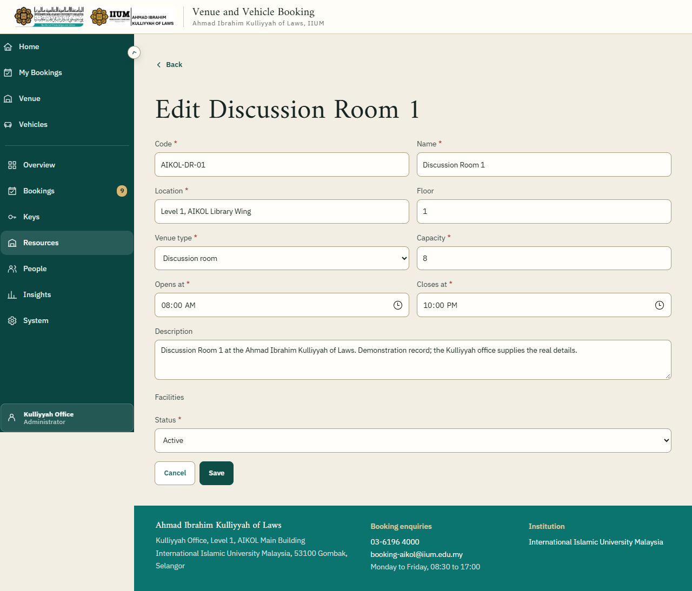
Editing a venue.
Photographs. Choose Images from a row's actions. Add several at once, or drag photographs onto the page. JPEG, PNG or WebP, up to 5 MB each. The arrows move a photograph earlier or later; the first one is shown everywhere else. A venue with no photograph shows a drawing instead.
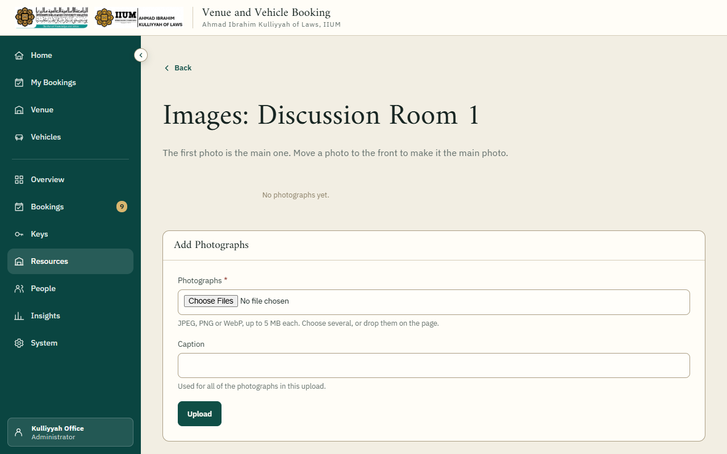
Images: the first photograph is the main one.
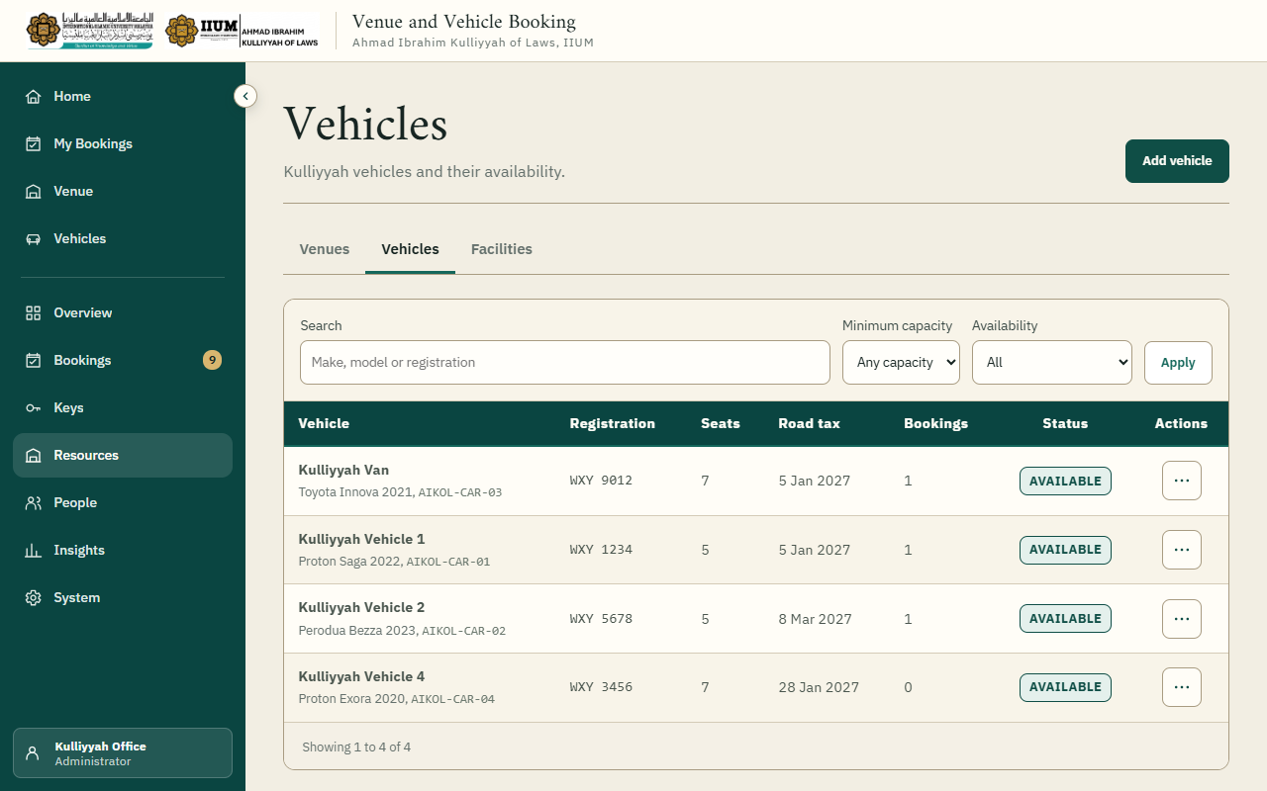
Resources, Vehicles.
Taking something out of use. Set its status to maintenance or inactive. It disappears from the requester's lists; bookings already made are not cancelled, so deal with each one.
Deleting. Only for a record entered in error. It must be made inactive first, and it must have no bookings at all. A venue or car that has ever been booked stays in the system, inactive, because the booking history needs it.
Facilities are the features a venue can have (projector, microphone and so on). Add, rename or stop offering them here, and drag the rows into the order they should appear on the venue form.
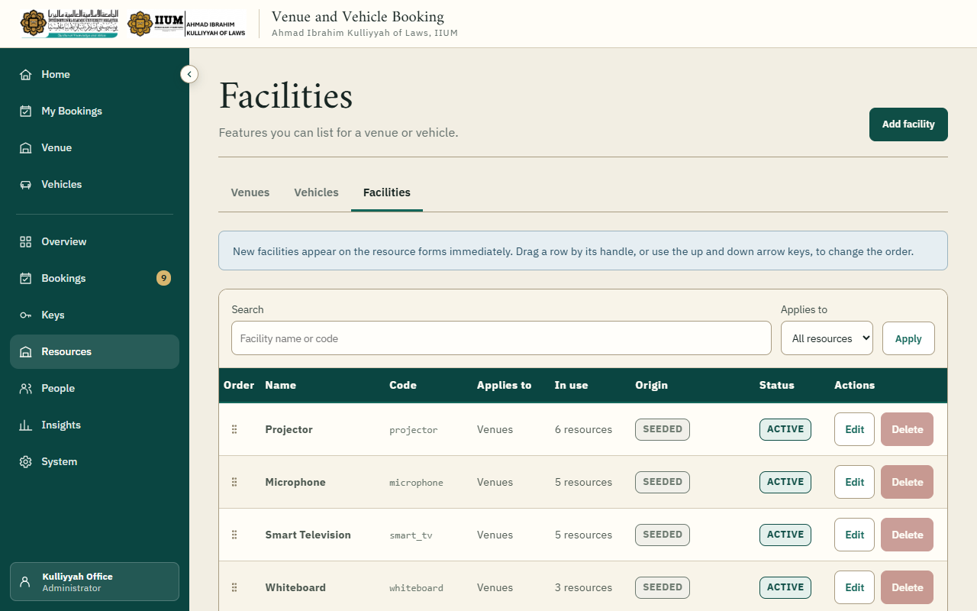
Resources, Facilities.

8. People
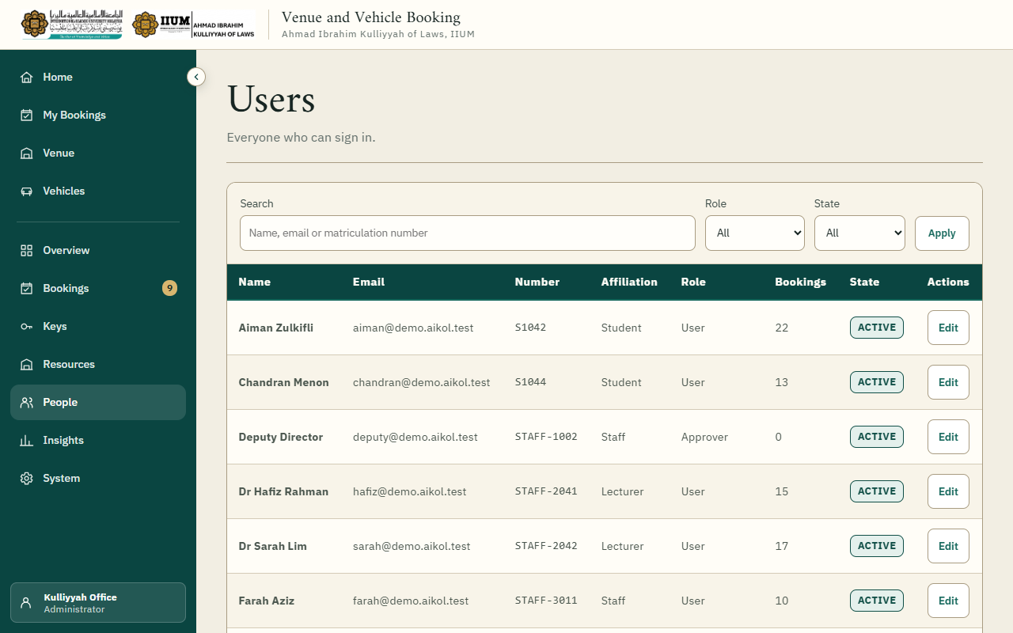
People: search by name, email or matriculation number; filter by role and state.
Open a person to change their details, affiliation or role.
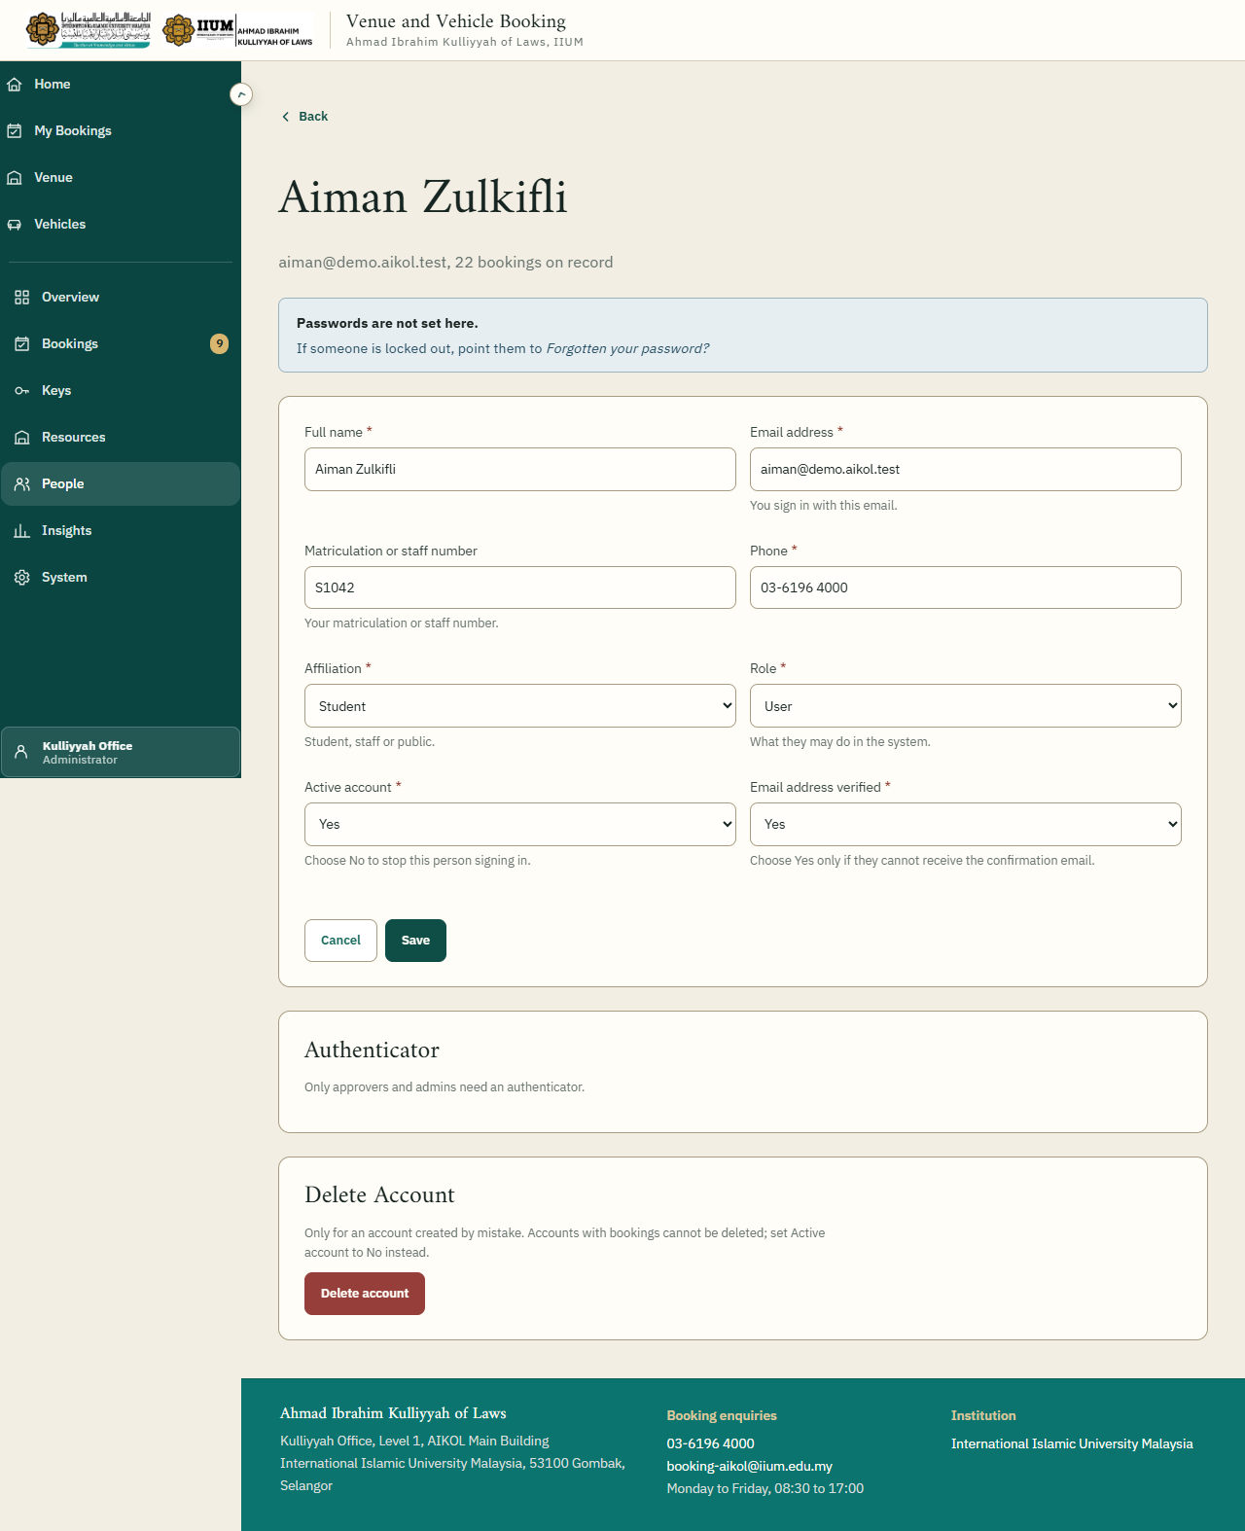
A person's record.
- Role. User, Approver or Administrator.
- Active account. Set to No to retire an account. The person cannot sign in; their booking
history is kept.
- Email address verified. Set to Yes yourself only when the verification email cannot
reach them.
- There is no password field. A person who is locked out uses Forgotten your password? on
the sign-in page.
- Delete account is for an account created in error. It must be retired first and have no
bookings. You cannot delete your own.

9. Insights
Reports for 30 days, 90 days or a year: bookings and approval rate, room demand by hour and day, bookings per month, how much each resource is used, keys, and the most frequent requesters.
Export bookings downloads every booking as a CSV file for Excel.
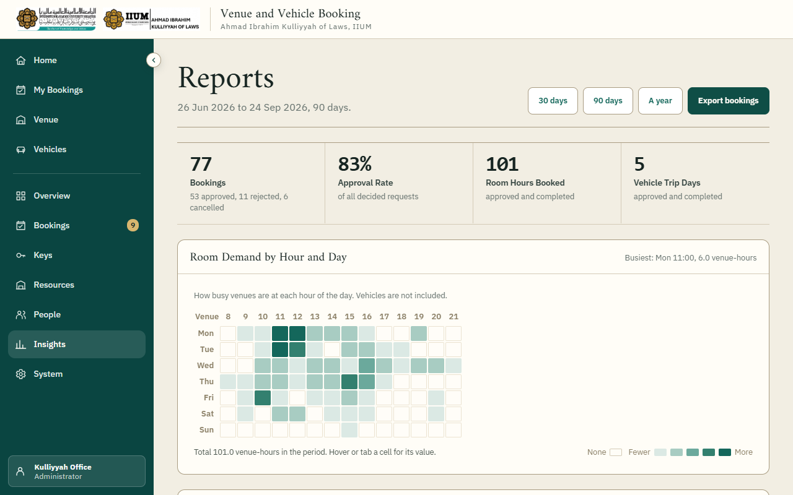
Insights.

10. System
The tabs across the top are Booking Rules, Academic Calendars, Site Content, Emails, Data and Audit Log.

Booking rules and email
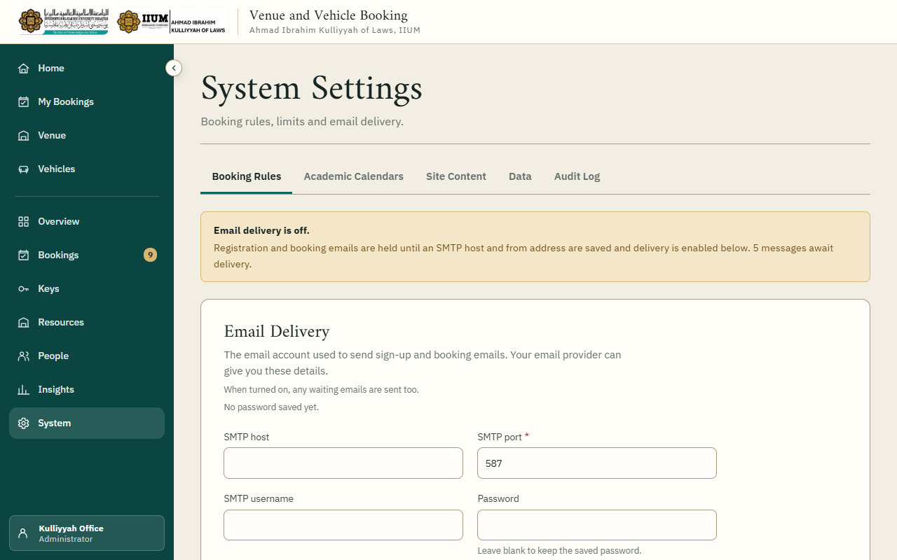
Booking Rules: email delivery at the top, then each rule with its own Save.
Email delivery. The SMTP details for the office mailbox. For Gmail: host smtp.gmail.com, port 587, encryption STARTTLS, the Gmail address as username and From address, and a Google App Password (not the normal password). Leave the password box empty to keep the stored one. Email delivery: Yes sends waiting messages within a minute. No holds them, which is useful while changing the settings.
Rules. Each has a plain description. Change a value and choose that row's Save. The rules the Kulliyyah confirmed are the defaults: 90 days ahead, nine hours longest, 08:00 to 22:00, 72 hours' cancellation notice, records kept seven years. Changes take effect straight away and are written to the audit log.

Academic calendars
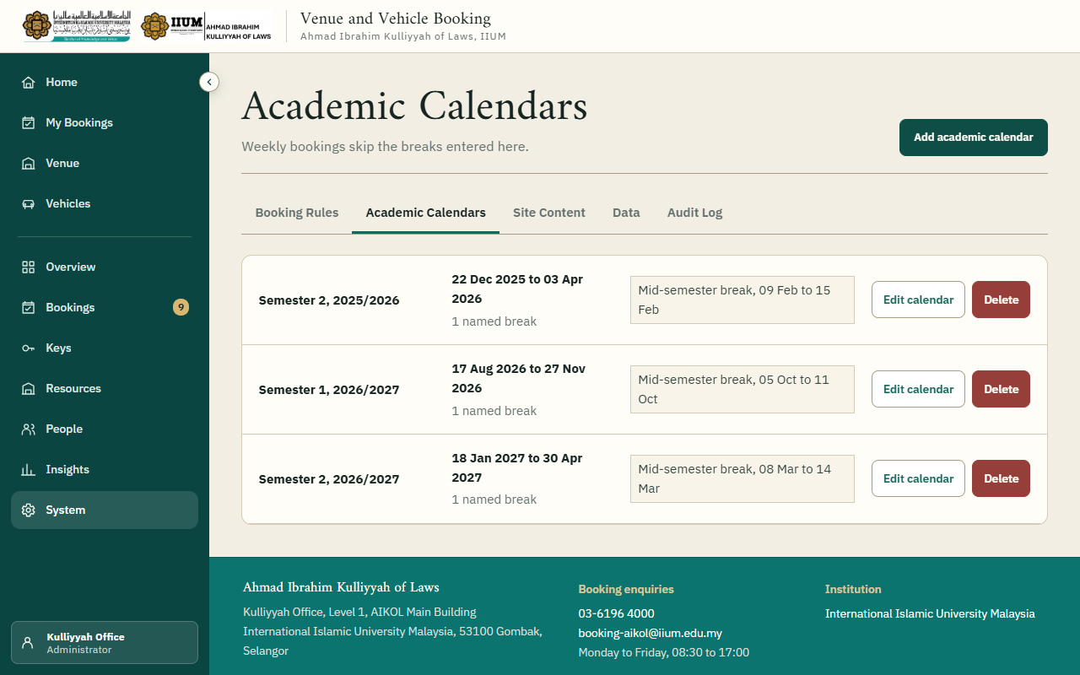
Academic Calendars: each semester with its breaks.
Each semester has a start and end date and its breaks. Weekly bookings are made against one of these: dates inside a break are left out. Semesters cannot overlap. Deleting a calendar does not touch bookings already made.

Site content and announcements
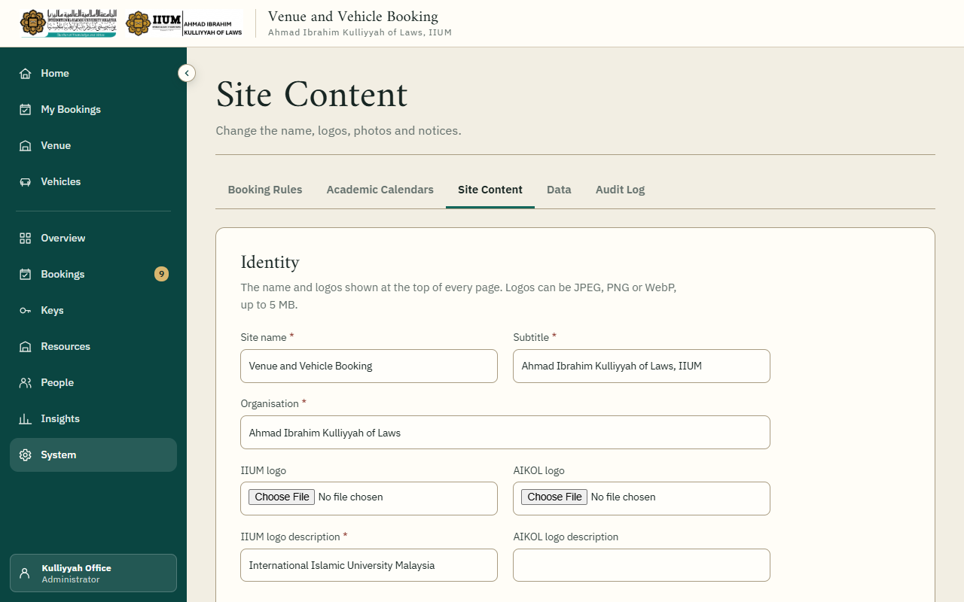
Site Content: each section has its own Save.
The name, logos, photographs and wording that appear in the header, the footer, the sign-in page and the home page. Remove image on a logo or photograph returns the built-in one.
Announcements appear on every requester's home page. Set a start and end time to schedule one, or set Published: No to take it down while keeping it on file.

Emails
Every email the system sends is listed here with when it goes out: booking received, approved, not approved, cancelled, the car's management decision, weekly bookings, confirming an email address, resetting a password, and accounts the office creates. Edited means the office has changed it; Default means it reads as it was installed.
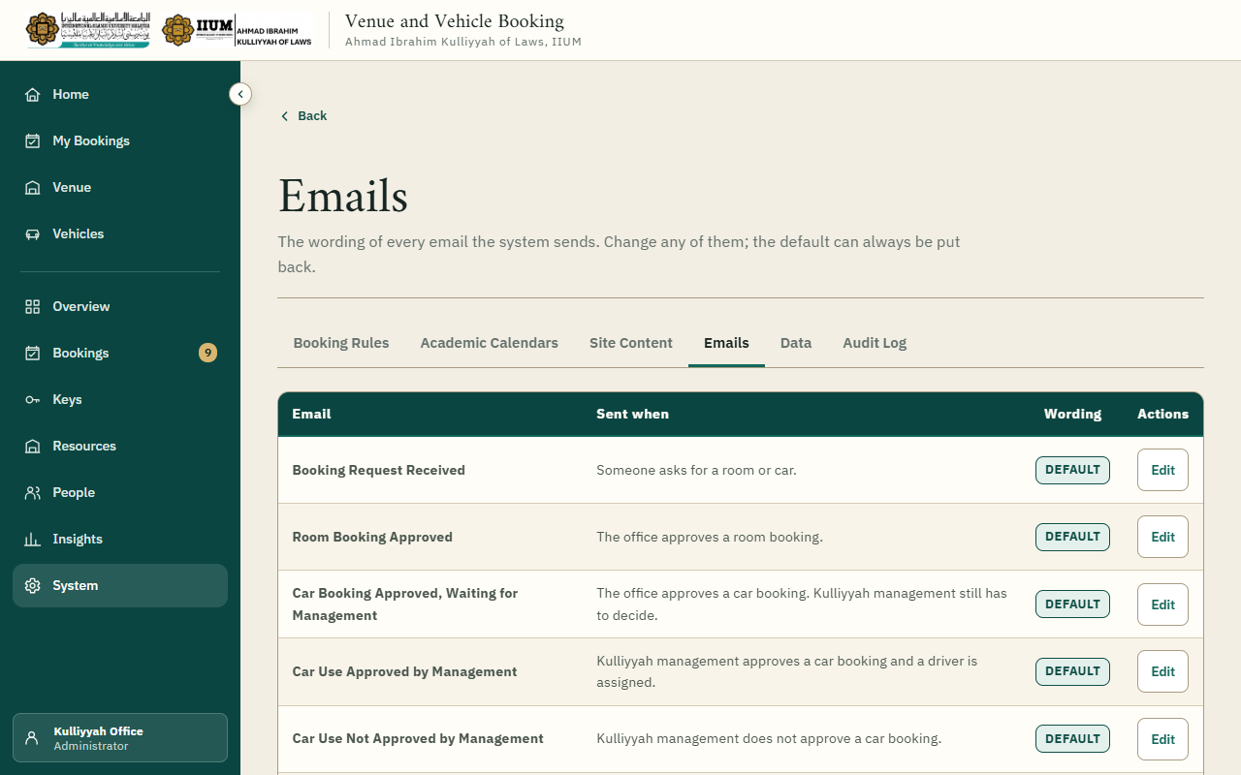
Emails: each email, when it is sent, and whether its wording has been changed.
Choose Edit to change an email's subject and message. Words in braces, such as {name} or {reference}, are filled in for each person; the list beside the form says what each one contains. Only those can be used, and a few must stay in: an email that asks someone to confirm their address or reset a password must keep {link}, and a rejection must keep {reason}.
Preview shows the email with sample details without saving it. Save uses the new wording from the next email onwards, and the change is written to the audit log. Put back the default wording undoes every change to that email.
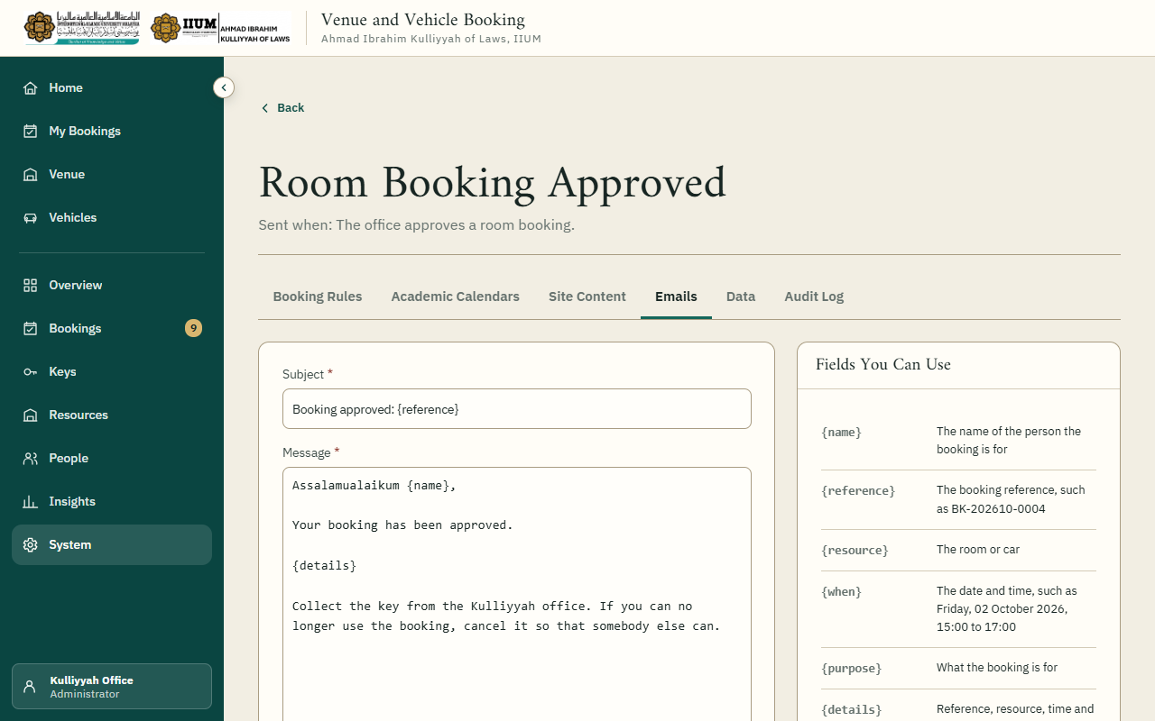
Editing an email: the fields it can use are listed beside the form.

Data
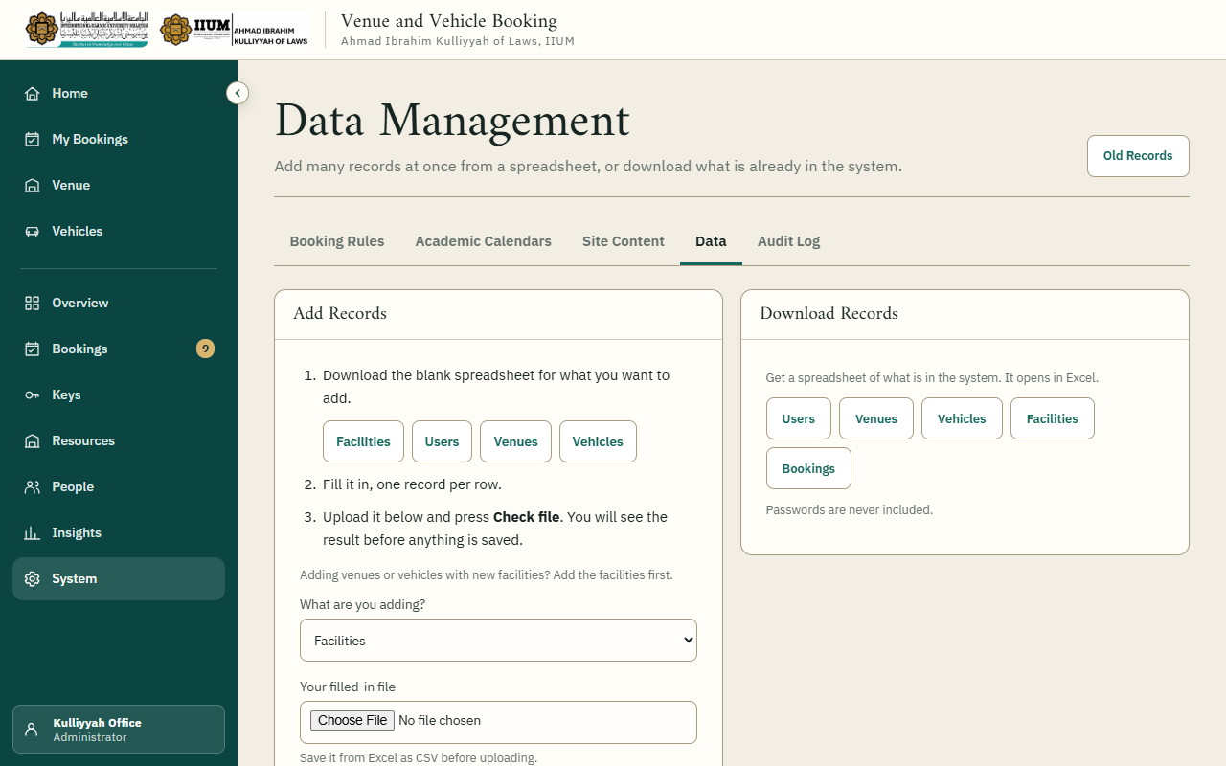
Data: import and export in CSV.
Download a template, fill it in in Excel, and upload it. Nothing is written until you have seen the preview: every row with a problem is listed with its line number and every reason, so the spreadsheet can be corrected in one go. Users, venues, vehicles and facilities can all be exported.

Audit log
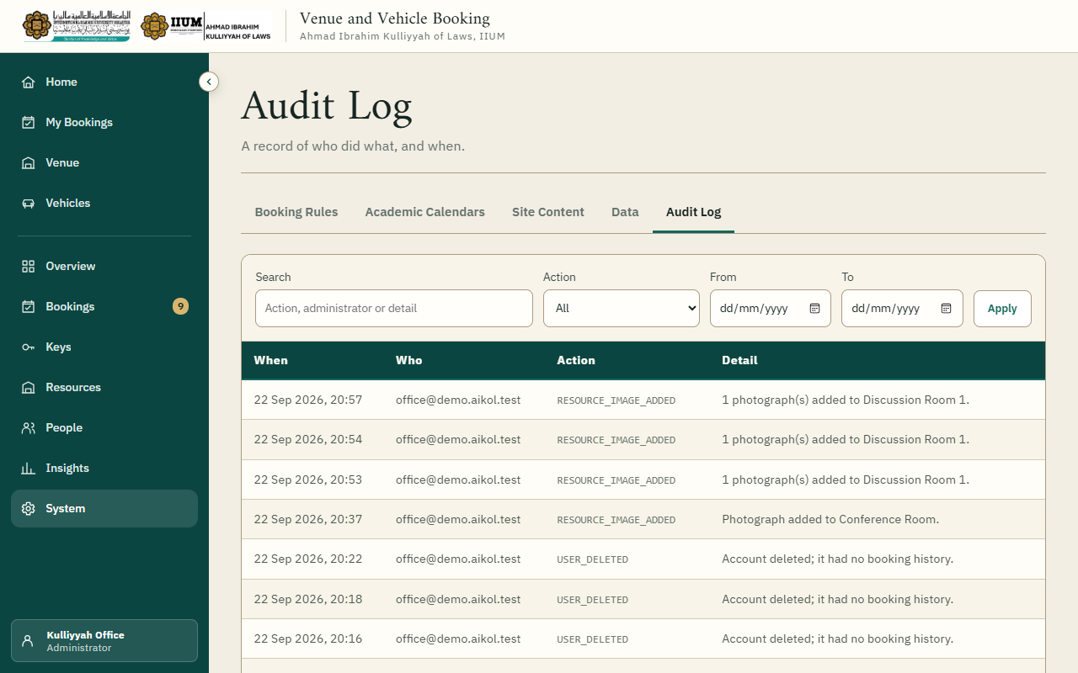
Audit Log: who did what, and when.
A record of every decision, change of rule, key handover and change to an account. Entries cannot be edited or removed.

Retention
Booking records are kept for seven years. Old Records, at the top of the Data page, shows how many are older than that. They are exported to a file and the copy checked before anything is removed, and nothing goes without you typing a confirmation.

A day in the office
- Overview: anything overdue?
- Bookings, Awaiting Decision: decide the queue, soonest first.
- Vehicle bookings approved yesterday: record the management decision and the driver.
- Keys: hand out today's keys; chase anything overdue.

If something goes wrong
What you see | What it means
Approval refused: "that period has been approved for another booking" | Someone else's request for the same time was approved first. Reject this one, or ask the requester for another time.
A key will not issue for a car | Management approval and the driver are not recorded yet.
Emails are not arriving | System, Booking Rules: check Email delivery is Yes and the App Password is right. The yellow notice counts the messages waiting.
"Set the time on the quarter hour" | Times run in quarter hours: :00, :15, :30 or :45.
A venue or car cannot be deleted | It is still active, or it has bookings. Make it inactive; that keeps its history.
A message that something did not reach the server | The reply was lost and the change may still have been saved. Reload the page and look before trying again.

The screenshots show fictional demonstration data.

